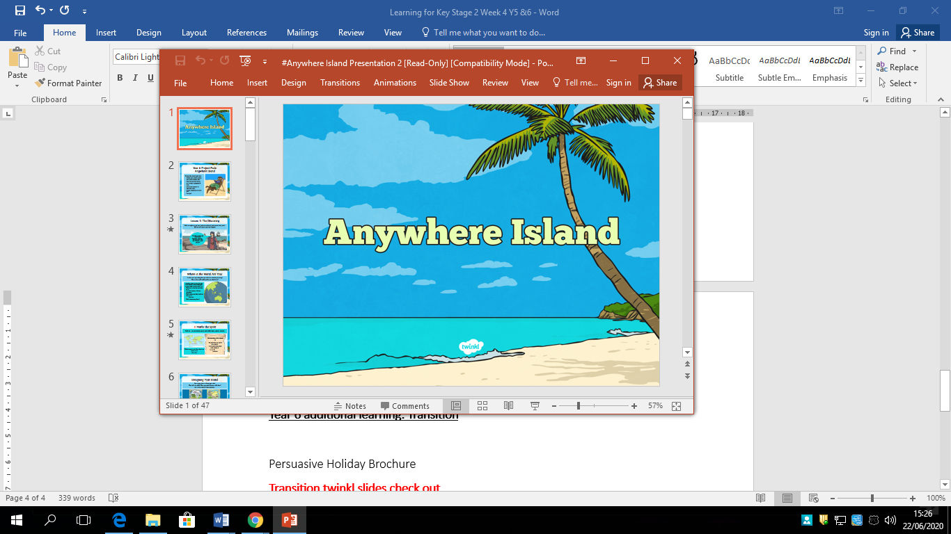

**What do you know about David Attenborough?**

**Write a biography about him.**

**Make sure you edit down any text you use from the internet.**