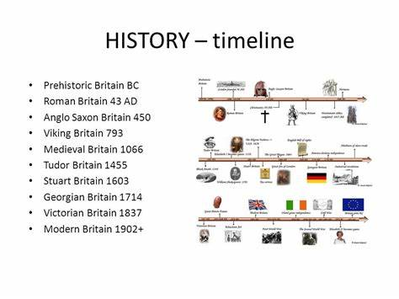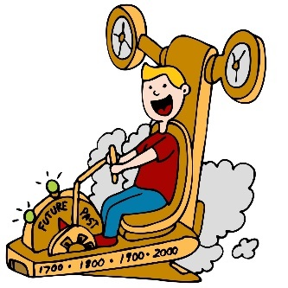

In Year 3 /4 I will know….

* show developing understanding of chronology by beginning to realise that the past can be divided into different periods of time.
* Use specific historical vocabulary including terms and periods – AD, BC, Modern, Ancient, decade, and related specific dates
* Use a timeline to categorise key features of specific time periods (people and places) and describe how they are different and similar to the present day.
* Use specific historical vocabulary including terms and periods empire, military ancient, exploration, civilisation.
* Understand specific time periods and be able to categorise them.
* Place several key events on a timeline within a time period.

**History Year 3 / 4**

**Chronology and Timelines**

* In Year 5 I will know….
* How to independently place events on a timeline for a period in history (Tudors, Egyptians)
* Remember key dates from a period of history (eg: Battle of Bosworth 1485, Death of Elizabeth 1 1603)
* Relate changes in the local area to key events in history.
* Compare differences in periods of history
* Use accurate time vocabulary to describe a period in history.

In Year 2 I knew….

* How to sequence 5 objects, events or objects in chronological order and give simple reasons to explain why
* Use more specific terms to describe the passing of time such as: when I was little, when my grandad was young, before my Granny was born, 100 years ago, recently
* Use a simple timeline to sequence famous sea explorers using key dates to support chronology