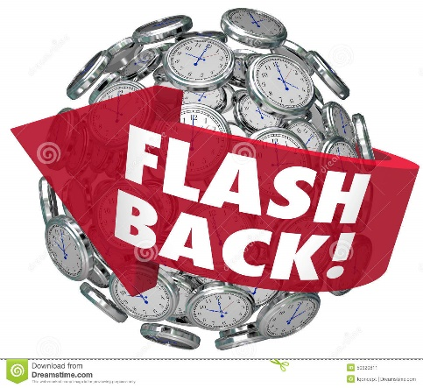

This year I will know….

* know about the life events in Tudor times eg: Henry VII, Battle of Bosworth, Death of Elizabeth I
* know about the USSR and USA Space Race and compare to modern space travel and exploration
* know about life of Ancient Egyptian Civilisations and key events such as burial rituals, the afterlife, Farming year, Egyptian hierarchy
* know about events in Victorian Britain eg: Industrial Revolution, inventions, medicines and reform
* Know about Charles Darwin, his discoveries and his significance in the wider world today.
* Know about the events leading up to and during WWII.
* Know about The Blitz, Battle of Britain, D-Day, Evacuation

**History Year 5 / 6**

**Life events beyond living memory**

In the future this knowledge could help me to become a…

* Museum curator
* Historian
* Journalist
* Artist
* Explorer
* Environmental scientist

In Year 4 I knew….

* know about the events in Roman Britain eg: Julius Caesar invasion, conquest of Hadrian’s wall
* know about the Viking and Anglo-Saxon raids and invasions
* know how potions were made for medicines in the past and significant medical discoveries eg: penicillin
* know how American Indian tribes compare to life in different periods of history