This year I will ….

* Begin to use some scientific language to talk and write about what I have found out.
* Begin to use comparative and superlative language.

**Science Year 3**

**Vocabulary**

**Working Scientifically**

In Year 2 I ….

* Use simple scientific language.
* Use comparative language – bigger, faster, heavier.

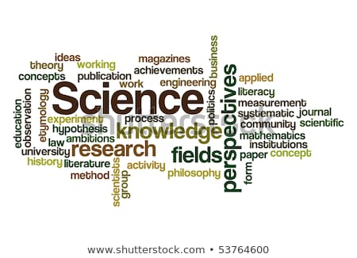

I will use this knowledge in Year 4 to ….

* I can use some scientific language to talk and write about what I have found out.
* I can use comparative and superlative language.