Dear Parents and Carers

Welcome to Stoneydelph Primary School.

Choosing the right school is one of the most important decisions you have to make as a parent or carer. Thank you for showing an interest in Stoneydelph Primary School.

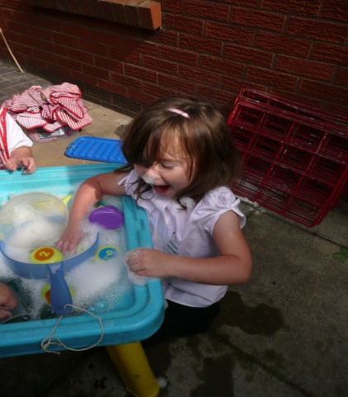

Our school caters for children from three years of age in our Daycare / Nursery through to learners of eleven.

We are a happy, caring and welcoming school promoting good manners and respect.

We value every member of our school community and our children are at the heart of all we do.

Our school has a hardworking, friendly staff, all of whom are committed to providing our learners with a ‘real and vivid’ range of exciting learning opportunities, in a caring and supportive environment, personalised to ensure the needs and interests of your child.

Our extensive grounds, excellent facilities and wide range of resources are used to support the learning of all.

We aim for high academic standards but also believe that the development of personal values, good behaviour, positive attitudes and enjoying learning are crucial to the development of all children.

Our pupils leave Stoneydelph as successful, confident and motivated learners, well prepared for the next step in their learning journey.

We believe that the partnership between parents and school is vital and we actively encourage you to be involved in your child’s learning.

This prospectus can provide you with information that you and your child will need to know about the daily life in school but is no substitute for a personal visit. You are warmly invited to contact us to arrange a visit to see our learners at work and experience our learning environment.

I look forward to meeting you and your child.

Mrs Jenny Wallbank BEd (Hons) MA NPQH

Head Teacher

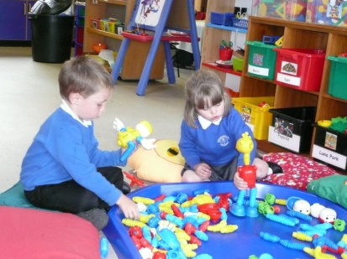**Stoneydelph Primary School**

**Learn Together – Achieve Together**

**Stoneydelph Primary School is a learning community providing children with the opportunity to develop as independent, confident, effective and responsible learners through an enriched, real and vivid curriculum.**

**In close partnership between pupils, parents, staff and governors, Stoneydelph Primary School aims to provide learners with:**

* a safe, secure and caring environment where everyone is valued and mistakes are accepted as part of learning
* the opportunity to develop positive attitudes, tolerance and respect for self, each other, the community, the environment and the world we live in
* the highest quality of appropriate learning challenges and highest standard of teaching in a stimulating learning environment – realising the high expectations and full potential of our learners and staff
* an enriched programme of visits, visitors and extra curricular activities to support learning.

**Stoneydelph Primary School promotes high achievement and continuous improvement by enabling all learners to:**

* have high self esteem and self motivation
* develop natural curiosity, social awareness, empathy and cultural understanding
* achieve high standards in communication, reading, writing, mathematics and the application of ICT
* confidently make moral judgements based on a personal set of beliefs and high values.

**As a learning community, Stoneydelph Primary School is committed to:**

* learning through investigation and first hand experiences
* positive relationships between home, school and the community
* 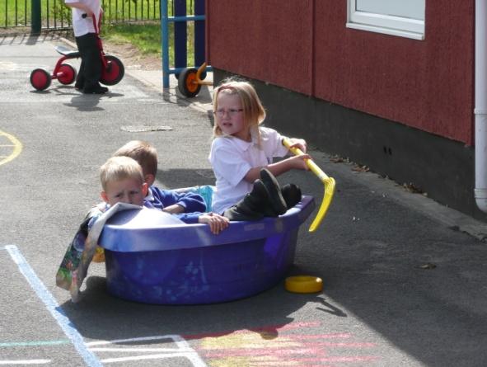an ethos of high quality support and encouragement
* work together for common goals.

**Stoneydelph Primary School is committed to UNICEFs ‘Rights Respecting School’ agenda.**

**Admissions**

Stoneydelph Primary School accepts pupils aged from 4 to 11 years old.

The standard number admitted in each year group is a maximum of 45.

In the event of over subscription, Staffordshire guidelines will be used to decide on the offer of places.

Stoneydelph Primary School accepts pupils from outside the immediate area,

provided places are available.

Parents are asked to register their child as soon as possible. Admission for a place in our Reception classes must be made to Staffordshire Admissions Office on 01785 278716.

To seek a place in Years 1 to 6, parents are asked to contact our School Office on

01827 896666.

The Headteacher, Mrs Jenny Wallbank, will be delighted to meet prospective parents and to make arrangements for visits at mutually suitable times.

**School Organisation and resources**

Stoneydelph Primary School is organised into twelve classes shared between four phases: Foundation stage includes a Nursery class and two mixed ability Reception classes; Key stage 1 is made up of three mixed aged and ability classes of Year 1 and 2 children; Lower Key Stage 2 has three mixed age and ability classes of Year 3 and 4 children and Upper Key Stage 2 includes three classes of our older learners –Year 5 and 6 learners organised into three mixed age and ability classes. In all phases, children are ability grouped or single year grouped at times so that staff can specialise and tailor the learning opportunities specifically to the needs of the learners.

Our classrooms are spread over two buildings with Foundation Stage (including our Nursery) and Key Stage 1 pupils situated in the upper building. This building also includes a hall, a specialist teaching reading room, a cookery room, a library and Stoney Tots Daycare base.

Key Stage 2 have their classrooms based in the lower building which also includes a hall, a computer room, a library, a number of small group study rooms and a Music Room. There is also a Hearing Impaired Unit attached.

The main school office and Head Teacher’s office are situated in the lower building.

We have three additional buildings on site which are used by our Before and After School Club and Sunshine Nurture Club. SureStart (Mother and Toddler), Barnardos, Rainbows, Brownies and Guides also make use of these additional rooms.

We are lucky to have extensive grounds, growing gardens and playground space for the children to use for outdoor learning and play.

The Governors have supported extensive investment in a new networked computer system, new networked laptops, Interactive White and Smart Boards, projectors and additional ICT hard and software to ensure that children’s learning benefits from the very latest technologies.

**The Stoneydelph Team**

**Governing Body:**

Chair: Miss Julie Price

Vice Chair: Mr Ray Newell

The Governing Body is made up of representatives from parents, the local community, teaching staff, non teaching staff and the local authority. A full list of Governors is available from school.

The Chair of Governors or any Governor may be contacted via school.

**Teaching Staff:**  (Spring 2012)

Headteacher: Mrs Jenny Wallbank

Deputy Head: Mrs Gemma Grainger

Senior Teachers: Mrs Lorraine Moore (Upper Key Stage 2 and Literacy Leader)

Mrs Stephanie Cotton (Teaching and Learning Leader)

Miss Sal Nagra (Lower Key Stage 2 and Numeracy Leader)

Mrs Caroline Hall (Key Stage 1 Leader)

Special Educational Needs Co-ordinator: Mrs Jenny Parry

Teaching staff: Mrs S Tyson, Mrs A Loughran, Miss N Munday, Miss D Fielding, Mrs T Myatt, Mr M Clarke, Miss L Philpotts, Miss K Eastwood, Miss S Heath, Mr D Brennan

Nursery Nurse: Mrs H Sadler

Teaching Assistants:

Mrs S Bates and Mrs K O’Neil (incl. 1’O’Clock Club)

Mrs S Thomas and Mrs L Warren (incl. Sunshine Club)

Mrs M Asbury, Mrs S Gardner, Mrs J Walker, Mrs A Udale, Mrs K Shelton, Miss S Kidner.

Office Manager: Mrs D Newell

Clerical Assistant: Mrs G Glass

Site Manager: Mr J Shaw

Site Technician: Mr S Hawker

Senior Midday Supervisor: Mrs Mary Stevens

Catering Team: County Caterers

Cleaning Team: County Cleaning

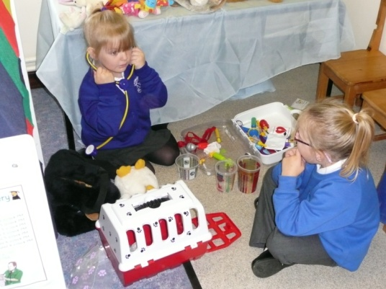**The School Day**

**Beginning and end of the school day**

* For Foundation Stage (Nursery and Reception classes) and Key Stage 1 (Year 1 and 2 classes) doors open at 8.45am for the children to come in to class and a bell at 8.55am marks the start of learning.
* The end of the school day for the Reception classes and Key Stage 1 is 3pm. Gates will be opened just before this time and parents / carers are invited to wait on the playgrounds for the children to be dismissed from their classroom doors.
* Further details specific to Nursery Session times are available in the Nursery booklet.
* Key Stage 2 children (Years 3, 4, 5 and 6) should wait on the Year 5/6 playground from 8.45am for the bell at 8.50am when they line up ready to go into class with their class teacher.
* Key Stage 2 children finish their learning at 3.15pm and are dismissed from their classrooms.

**Children arriving after 9am must report to the school office** first as external doors to both buildings will be locked and registers will have been completed.

We teach all children that if their parent/carer has not arrived at the end of school, they must wait at the school office.

**We ask that parents and carers advise the school office if they are delayed, so that your child can be reassured.**

In the unlikely event of a delay of over 30 minutes, your child will be taken to after school club – please be advised there is a charge for this.

**Attendance**

The Educational Welfare Officer regularly visits school to check on attendance and will follow up all concerns and any absences that are unaccounted for. Failure to send your

child to school may result in legal proceedings.

If possible, medical and dental appointments should be made out of school hours, but we

appreciate that this is not always possible.

.

**Health and Safety**

**Absence**

In accordance with DfE regulations, you must notify the school if your child is absent for any reason. Please be aware that if your child is absent and we have not received a message from you, we will phone you.

C:\Documents and Settings\headteacher\Local Settings\Temporary Internet Files\Content.IE5\E1K1L7KE\MC900360982[1].wmf

If your child has an illness that may be contagious, please check with the school office before sending your child to school.

If your child has suffered with sickness or diarrhoea, please keep them at home for 24 hours after the last bout.

**Emergencies**

If your child has an accident or becomes unwell during the school day we will telephone to inform you.

If your child receives a bump to the head, we will telephone to advice you and monitor during the afternoon.

If you are unavailable to speak with, we will contact the emergency contacts named on your child’s admission form.

**It is therefore crucial that you keep us informed of any changes of telephone number.**

**Medicine**

We are only able to administer medication prescribed by a doctor when an indemnity form has been completed. These are available from the school office. **Medication must be handed in at the office and should not be kept in your child’s bag.** If it is necessary for your child to take medication longer term, a care plan will be created by the school nurse in consultation with you.

**School meals**

dglxasset[1] Meals are available everyday and are freshly cooked on the school premises and served in the Key Stage 2 hall. Lunchtime supervisors are available to support children with table learning table manners, cutting up food and clearing their plates away.

Meals are served in a cafeteria style and children can choose from a variety of dishes and deserts each day.

The weekly menu is available on the notice board outside the Key Stage 2 hall and from the school office. Meals are paid for and ordered on a daily basis.

The school kitchen can also prepare pack lunches for children which can be put in their own lunchbox if preferred.

If you think you may be entitled to free school meal or packed lunch, please talk in confidence to the staff in the school office. They have application forms available.

**Even if you choose for your child to not take up a free meal, please let the office know if you are entitled to one. The number of Free School Meal children we have registered impacts on the amount of funding the school receives.**

dglxasset[1]**Sandwich Meals**

Sandwich and packed lunch meals are provided by parents / carers and

are eaten at tables in the Key Stage 1 hall. Lunchtime supervisors are available to support children with learning table manners, opening food and tidying away. Packed lunches must be brought to school in a lunch box or container clearly labelled with your child’s name.

For safety, cans, glass bottles and flasks are not allowed.

If your child forgets their packed lunch, please let us know if you will be bringing it to school. If you are unable to, we will provide a school dinner which you will need to pay for the following day.

**Water Bottles**

All children are encouraged to drink water throughout the school day. Children need to bring a named water bottle with a sports cap to school. There are water coolers available in both buildings so that children can refill their bottles during the school day. Please remember to sterilise or replace bottles regularly. Bottles are available to buy from the school office.

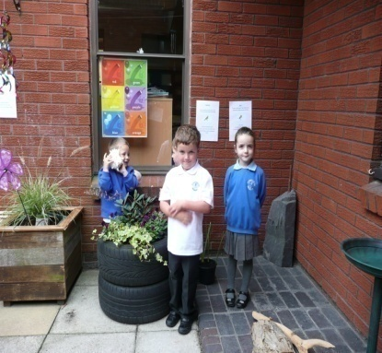**dglxasset[2]**

**The School Uniform**

The school colour is royal blue. All items of uniform with the school logo are available from Buxton and Bonnett, other items are available in stores and supermarkets in Tamworth.

The uniform we encourage is:

**Boys Girls**

Royal blue jumper or sweatshirt Royal blue cardigan, jumper or sweatshirt

White polo shirt White polo shirt

Grey or black trousers (or shorts) Grey or black skirt, pinafore or trousers

Blue check dress (summer)

Royal blue fleeces and fleeced raincoats with the school logo are also available for boys and girls.

Book bags printed with our school logo are available for to buy from the school office

**PE Kit**

Plain white t shirt Plain shorts

Black pumps Track suit and trainers (for outdoor games in winter)

Drawstring named bag for storing kit.

**dglxasset[1]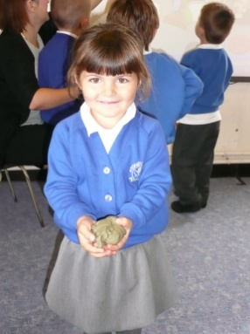 We ask that all items of uniform – especially jumpers and sweatshirts - are clearly named so that if they are mislaid they can be returned to your child.**

**Jewellery and Watches**

**For safety reasons, we advise jewellery and watches should not be worn in school.**

If your child has a pierced ear / ears then small studs should be worn.

In accordance with Local Education Authority guidance, all jewellery including stud earrings must be removed for PE lessons. If your child is unable to remove their own earrings we suggest none are worn on PE days as staff can not be expected to take earrings in or out.

During the initial 6 week period when first pierced, earrings can be covered with surgical tape provided from home during PE lessons.

**dglxasset[1]Mobile Phones** Children do not need to have their mobile phones in school. We do, however, understand that as Year 5 and 6 children start to walk to and from school on their own, parents may want their child to have their mobile phone with them in case of an emergency. In this instance your child must leave their mobile in the school office first thing in the morning and collect it at the end of the school day.

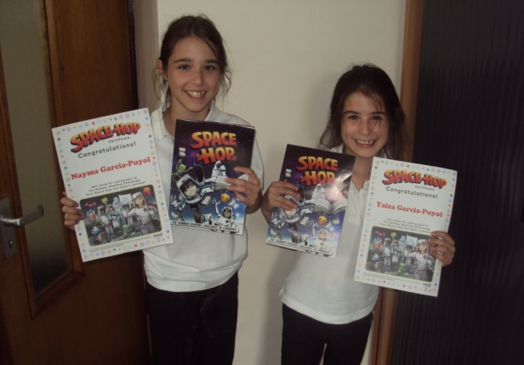**Any child found to have not handed their mobile phone in will have in confiscated and it will need to be collected from the school office by a parent/carer.**

**Home and School working together**

If you need to see your child’s class teacher it will be more convenient to chat before or after the school day, when the teacher is not busy with the class and is able to devote their time and attention to you. It is always best to check with the school office or phone school beforehand to agree a mutually convenient time.

The Deputy Head and Head Teacher are also always pleased to meet with you. Please bear in mind though that it may be necessary to make an appointment - phone or check with the school office.

If you have any queries or concerns, please don’t hesitate to contact us so that we can help. Alternatively, please e mail:

[office@stoneydelph.staffs.sch.uk](mailto:office@stoneydelph.staffs.sch.uk) or [headteacher@stoneydelph.staffs.sch.uk](mailto:headteacher@stoneydelph.staffs.sch.uk)

Please watch out for opportunities to come and share your child’s learning in school. Throughout the year there are concerts, special assemblies, open mornings/afternoons and specific information evenings. In addition there are ‘Parent Consultation Evenings’ in the Autumn and Spring Terms and an Open Evening in with the opportunity for a private appointment to discuss your child’s progress alongside a written report in the Summer Term.

Regular newsletters and letters about specific school events are sent home with children. The school website is also a useful source of information – with policies, pictures and information. The address is: [www.stoneydelph.staffs.sch.uk](http://www.stoneydelph.staffs.sch.uk)

Parents will also soon gain access to the school learning platform.

**Special Educational Needs / Learning Support**

Please let us know if your child has any problems which may affect his/her learning, e.g.

speech, eyesight, hearing, medical conditions, physical needs, social concerns.

If your child is finding learning more difficult than his/her peers, we will contact you to discuss how he/she can be helped to improve.

Our Special Education Needs Co-ordinator (SENCO) is Mrs Parry..

If necessary, your child’s name will be added to the Learning Support/Needs register. This will ensure your child receives appropriate help through School Action or through work with other support agencies. Your support in this process is essential and we will contact you regularly to let you know about your child’s progress.

We use the expertise of the Staffordshire Support Teams and other specialists to meet the needs of children with additional learning needs.

We can also refer children/families to our Family Support Services and provide details of how parents can access help for home support, in full confidence.

You are always welcome to discuss your child’s progress with staff. An appointment helps to ensure adequate time is available for you and the teacher.

**More Able Pupils**

If your child finds learning easier than peers or has a particular talent, we will do all we can to use more challenging tasks in order to help him/her achieve his/her full potential. We want every child to be the very best they can in academic subjects, sports and the arts. We work in partnership with local schools to create master classes and workshops for groups of able, gifted and talented learners.

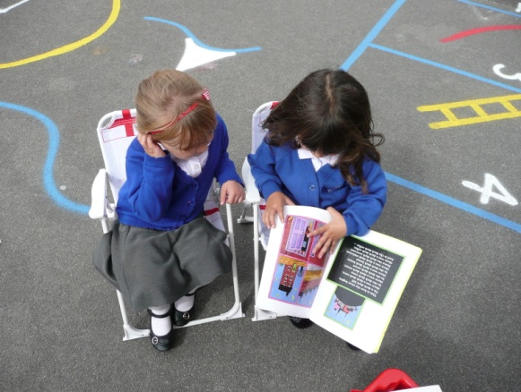

**Homework**

Homework refers to an activity or research that our learners are asked to complete at home, on their own or with their parent / carer.

**Why set homework?**

* Homework helps to reinforce learning that has been completed in lessons
* It helps to extend school lessons
* It encourages children to learn to study on their own
* It allows parents / carers to engage with the child’s learning
* It provides opportunities for parents, children and school to work in partnership.

All children are expected to complete their homework to the best of their ability but it should not be a battle. **If your child is experiencing difficulties in completing a home learning activity, please speak with your child’s class teacher.**

Each phase of school life has different home learning expectations based on reading, spelling, maths and topic related research.

The Autumn Term newsletter sent out by your child’s class teacher will inform you of time and completion expectations.

Every child has a reading and home learning diary to record the learning completed.

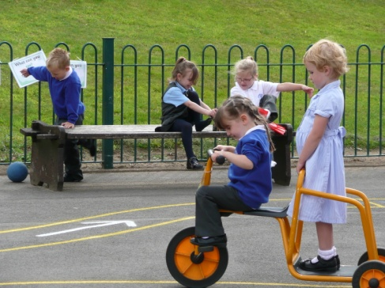**To help your child, parents are encouraged to:**

* Provide a reasonably quiet, suitable place for your child to do their home learning
* Praise and value homework and support the school homework policy
* Encourage a little often rather that all in one go.

**Breakfast and After School Clubs**

We are able to offer breakfast club session in the Community Room, from 8am, for a small charge. Cereals and toast with a drink of squash are provided and children have the opportunity to play games and take part in activities until the start of the school day.

Our after school club is also run from the Community Room and is open until 6pm. Children have a snack, drink and access to games and activities.

Please ask at the School Office for further information.

**Lunch and playtime**

Children have a mid morning 15 minute break at 11am. Children are able to play out on their designated playgrounds (Year 1/2; Year 3/4; Year 5/6).

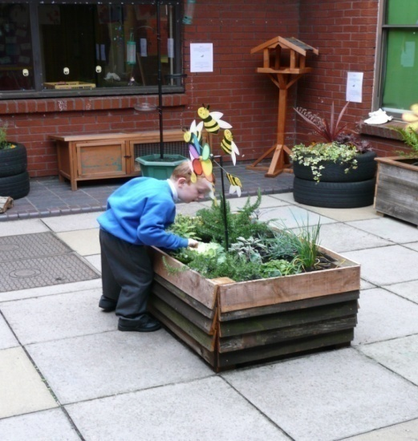During this playtime, Key Stage 1 learners have access to a piece of fruit or, like the Key Stage 2 children can bring a fruit or healthy snack from home or purchase toast, crumpet, fruit, milk or orange juice. Parents can pay for this weekly on Mondays (Key Stage 1) or daily (Key Stage 2).

Learners in the Reception classes are able to access a fruit snack and drink of milk or water throughout the day.

Lunchtime is from 12.15 until 1.15pm. If your child is going home for lunch, we request you collect and return your child to the school office. Year 6 children can go home alone but it is requested that parents/carers inform the office of this arrangement.

**Safety around the school site**

We make regular checks of the school site and equipment to ensure that it is safe for our children. You can also help to keep all of our learners safe by:

* reporting to the school office first if you need to visit school for any reason during the school day;
* not bringing your car onto school property and taking care when parking in the roads around school at the beginning and end of the school day;
* not bringing dogs onto the school property;
* not taking other people’s children home unless the class teacher has been informed by the child’s parents.

**Care and Safeguarding Children**

Under the Education Act 2002 (section 175), schools must make arrangements to safeguard and promote the welfare of children. Parent/carers should know that the law (Children Act 1989) requires all school staff to pass on information which gives rise to a concern about a child’s welfare, including risk from neglect, physical, emotional or sexual

abuse. The staff will, in general, discuss any concerns with the parent/carer, and where

possible, seek their consent to a referral to children’s team / agencies. However, this

will be done only when such discussion does not place the child at increased risk of significant harm. Schools will seek advice when they have reasonable cause to suspect a

child may be suffering or likely to suffer significant harm.

Occasionally, concerns are passed on which are later shown to be unfounded. Parents/carers will appreciate that the designated person for child protection was carrying out their responsibilities in accordance with the law and acting in the best interest of all children.

All staff and volunteers are required to have CRB checks before working with our pupils.

The school will take appropriate disciplinary action when pupils/adults endanger the safety of others or breech school policies.

**Behaviour and Anti –Bullying**

Our agreed school aims and values include that we should work together to provide:

* a safe, secure and caring environment where everyone is valued and mistakes are accepted as part of learning
* the opportunity to develop positive attitudes, tolerance and respect for self, each other, the community, the environment and the world we live in

Our school rules, agreed with our learners support this:

* treat other children and adults with respect
* never hurting other children or interfering with their property
* 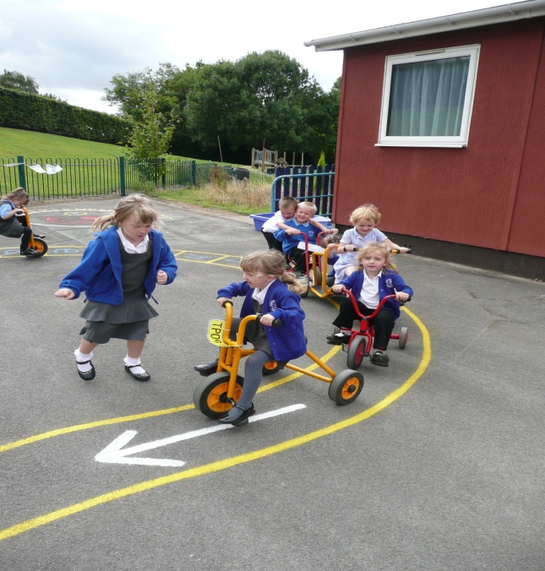take care of the school building, grounds and property.

A small minority of children sometimes show behaviour that is unacceptable and for those children there are a clear set of sanctions contained within our behaviour policy.

We also have a clear set of procedures of how we deal with incidents of bullying. They are contained within our Anti Bullying Policy.

Both policies are reviewed regularly in consultation with our learners, parents and staff and are available from our school office or on our website.

**dglxasset[3]After School and lunchtime clubs**

We have a wide range of after school activities

available, at different times of the year, to different key stages of children.

These include:

Cooking Gymnastics Football

Dance Netball Art

Choir ICT Indoor and outdoor athletics

Some clubs are also available at lunchtimes.

**Fun activities that make learning fun**

We also organise extra activities and visits to support our learning in school. These include:

* Visits to the theatre and other specialist places that help bring learning to life
* Bikeability training for Year 5 and 6 learners
* Archery workshops
* A residential visit to Laches Wood for Year 6 learners
* Dance workshops
* Drumming workshops
* Plays and concerts
* Special theme days
* Artists, Storytellers and other specialist visitors to lead learning workshops
* The local football team and other sports specialists
* Police, Street Wardens, Fire Service, Nurses and other professionals.

**Parent Helpers**

Parents are invited to help with practical tasks - running the library, practising reading

with children, helping to prepare and maintain resources, etc. We encourage all parents

and grandparents to help with gardening, decorating etc. Please let us know what talents

and skills you have.

In order to keep our children safe, a Police Check will be necessary before you work with children.

**Charges and Remissions Policy**

Voluntary Contributions - The school will seek contributions from parents for aspects of

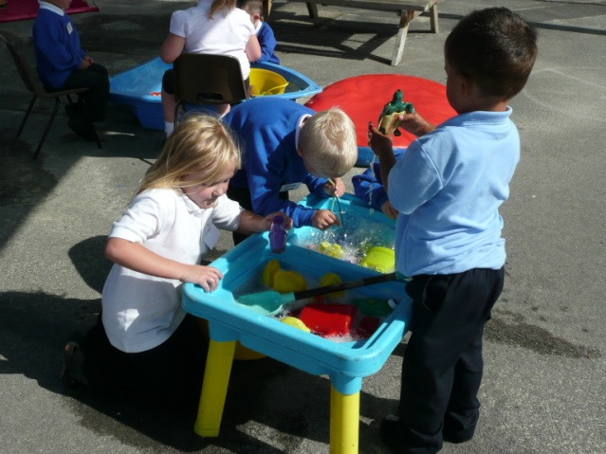children's education which may take place outside the school precincts or when artists are working in school and there is a cost. There is no limit to the level of voluntary contribution, neither is there an obligation on parents to pay. We keep costs as low as possible. However, it must be understood that without such contributions, planned activities may be cancelled if costs cannot be covered.

Where parents have financial difficulties, the school may operate a confidential Remissions Policy. Please contact the office or Headteacher if you wish to discuss this in confidence.

**Holiday Leave**

Holiday leave is not granted automatically.

Parents are required to provide written evidence from employers that holiday leave cannot be taken outside term time.

If a family holiday in school time is unavoidable, an application form for holiday leave must be filled in, in advance for authorisation.

Holiday leave will not be authorised during SATs periods, or during the first week of Autumn term. The Staffordshire point system is used to calculate authorisation.

It is school policy that additional work is not set to cover holiday absence, as parents have a responsibility to ensure their children attend school during term time.