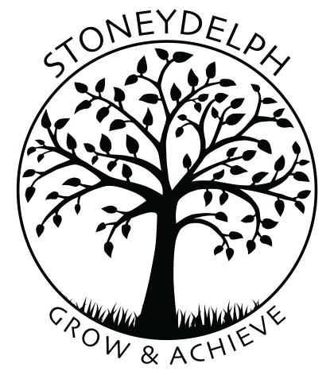
Stoneydelph Primary School
Curriculum
Intent
At Stoneydelph we aim to provide our learners with a well-rounded curriculum that will provide a wide range of memorable experiences that will inspire our pupils to learn, enhancing their life skills, their knowledge and understanding, their confidence and their ambition to succeed in all they do. We aim to foster positive attitudes to learning with our pupils with the opportunity to develop of perseverance, tolerance, resilience and respect.
Implementation
We feel it is important at Stoneydelph for our learners to understand the links between aspects of their learning; their learning and the local community and their learning with the wider world. We provide interactive, creative learning activities with hands on experiences that provide opportunities for all learners to make progress and shine! Our curriculum incorporates the statutory requirements of the Early Learning Goals of the Early Years Foundation Stage and the National Curriculum 2014 and additional experiences and opportunities that we fell best meet the learning and developmental needs of our pupils.
Impact
At Stoneydelph Primary School, we inspire our pupils to be confident, independent and successful learners who strive to do their best due to their high aspirations and who know how to make a positive contribution to their community and wider society, being well prepared for life in modern Britain. Our learners enjoy their education, demonstrate good manners and have a positive moral, spiritual, social and cultural understanding. We provide a highly inclusive environment where pupils at all levels are helped to achieve their potential. More able pupils are challenged to expand their skills and knowledge. Those who find learning more difficult are supported to embed skills and learn in a style that best suits their needs. Our learners feel confident to explore, question, reason and have a go – safe in the knowledge that making mistakes supports deeper learning and understanding.

