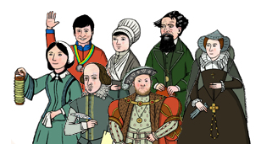

This year I will know….

* about the Roman Empire and the rulers during the eruption of Mount Vesuvius
* about the significant people in ancient Greece, such as Alexander The Great and his impact on life in ancient Greece and modern Greece
* about historical vocabulary, such as empire, AD BC, ancient, civilisation and exploration
* about important ancient Greek athletes and compare them to modern athletes such as Mo Farah
* about Stone Age Man and life in a tribe
* about Anglo Saxon/Roman invasion and key figures such as Julius Caesar and Boudicca and how they impacted on the world.
* Compare the leaders of invasion and exploration from Tudor times to Viking/Roman invasion and exploration
* Compare Stone Age Man to Native American Indian Tribes and how this life has shaped the modern day

**History Year 3 / 4**

**Learning about the lives of significant people**

In Year 5 I will know….

* About significant Tudor leaders such as Henry VIII and how they led their people into battle and compare to Roman/Viking soldiers and battles and conquests
* About Ancient Egyptian Pharaohs and compare to Emperors from other Ancient civilisations.
* Know about significant figures from Tudor and Victorian Era and during WW2 how they brought about social reform and change which then impacted on modern life.

In Year 2 I knew….

* about famous engineers and how they build important buildings and structures such as Isambard Kingdom Brunel during the Victorian times.
* who Robert Peel was and how he was important in the local area and in our country in Victorian times.
* about the lives of famous Tudor explorers such as Christopher Columbus and how their exploration gave us knew knowledge of the world and traded goods between countries.