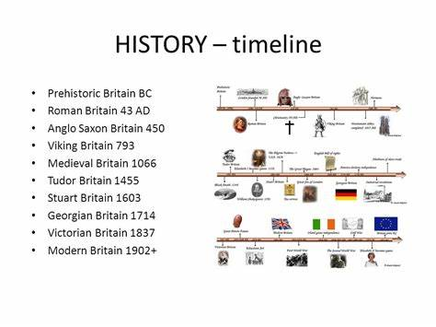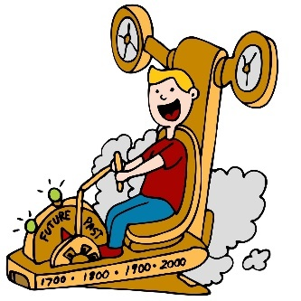

In Year 5 / 6 I will know….

* How to independently place events on a timeline for a period in history (Tudors, Egyptians)
* Remember key dates from a period of history (eg: Battle of Bosworth 1485, Death of Elizabeth 1 1603)
* Relate changes in the local area to key events in history.
* Compare differences in periods of history
* Use accurate time vocabulary to describe a period in history. How to select, organise and present timelines for a given period of history (such as WW2) or a range of periods from the past
* Sequence key events from Ancient civilizations (Maya / Shanghai), Victorian period on a timeline, explaining the changes over time using accurate historical vocabulary.
* Create from memory a timeline to show the history of Polar exploration
* Use a wide range of different evidence to collect evidence about the past.

**History Year 5 / 6**

**Chronology and Timelines**

In the future this knowledge could help me to become a…

* Museum curator
* Historian
* Journalist
* Artist
* Explorer
* Environmental scientist

In Year 4 I knew….

* How to use specific historical vocabulary including terms and periods – AD, BC, Modern, Ancient, decade, and related specific dates
* Understand specific time periods and be able to categorise them
* Place several key events on a timeline within a time period.
* military ancient, exploration, civilisation.