**Science Year 6**

**Living things and their habitats. (Biology)**

In Year 5 I knew….

• Describe the differences in the lifecycles of a mammal, an amphibian, an insect and a bird.

• Describe the life process of reproduction in some plants and animals.

This year I will know….

• Describe how living things are classified into broad groups according to their common observable characteristics and based on similarities and differences, including microorganisms, plants and animals.

• Give reasons for classifying plants and animals based on specific characteristics

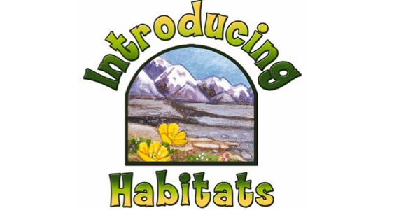

In the future this knowledge could help me to become a…

• A veterinarian,

• Animal behaviourist,

• A zoologist,

• A conservationist,

• A naturalist,

* A micro biologist,