Reading Curriculum Coverage – LKS2
Developed by: Year 3 & 4 Compiled: March 2022
Cycle A – Academic Year 2021-2022
Year 3 / 4
Autumn 1 | Autumn 2 | Spring 1 | Spring 2 | Summer 1 | Summer 2
Invasion  (History Driver) | Misty Mountains  (Geography Driver) | Ancient Civilisations  (History Driver) | Predator  (Science Driver) | Burps, Bottoms and Bile  (Science Driver) | Potions  Can we block sound?  How far can sound travel?  (Science Driver)
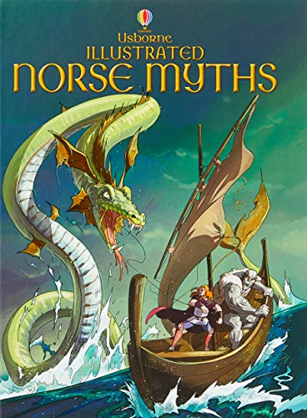 | 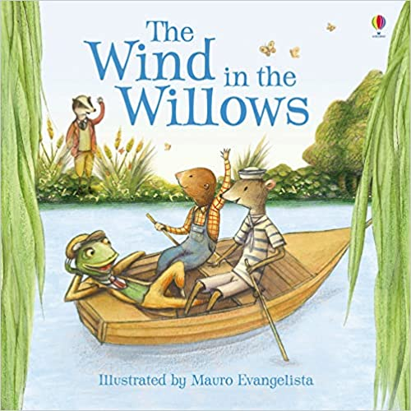 | 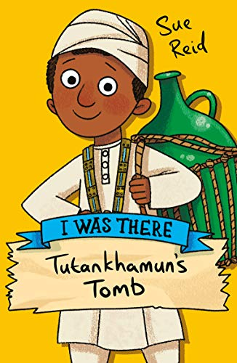 | 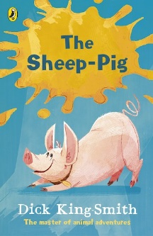 | 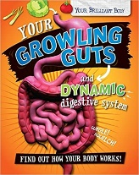  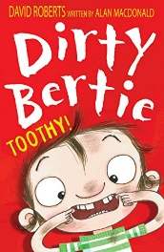 | 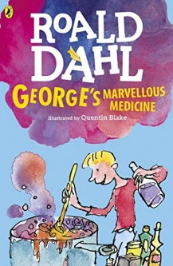
Usborne Illustrated Norse Myths  by Alex Smith and Louie Stowell  (Historical Fiction) | Wind in the Willows  By Kenneth Graham  By  (Fantasy Adventure) | I Was There  Tutankhamun’s Tomb  By Sue Reid  (Action Adventure Story) | The Sheep Pig  By Dick King Smith  (Contemporary Fiction Story) | Your Growling Guts  By Paul Mason  (Non-Fiction) | George’s Marvellous Medicine  by  Roald Dahl  (Contemporary Fiction Story)

Cycle B – Academic Year 2020-2021 & 2022-2023
Year 3 / 4
Autumn 1 | Autumn 2 | Spring 1 | Spring 2 | Summer 1 | Summer 2
Through the Ages  (History Driver) | Rocks, Relics and Rumbles  (Geography Driver) | Mighty Metals  (Science Driver) | Road Trip USA  (Geography Driver) | Scrumdiddlyumptious  (Design and Technology Driver) | Emperors and Empires
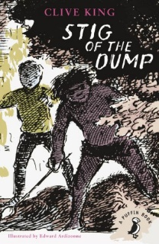 | 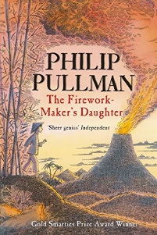 | 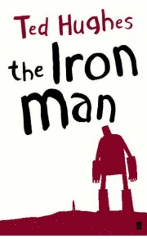 | 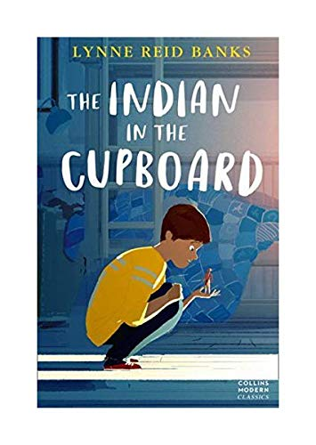 | 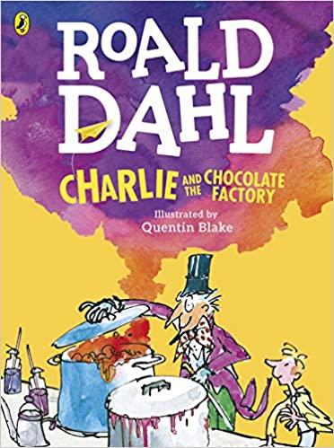
Stig of the Dump  By Clive King  (Modern Classic) | The Firework Makers Daughter  (Cultural Short Stories) | The Iron Man  By Ted Hughes  (Fantasy Fiction) | Indian in the Cupboard  By Lynne Reid Banks  (Modern Classic)) | Charlie and the Chocolate Factory  By Roald Dahl  (Fantasy Adventure Story) | (Non-Fiction)

