**Science Year 4**

**Living things and their habitats. (Biology)**

In Year 2 I knew….

• Know the difference between things that are living, dead and have never been alive.

• Know what a habitat and micro habitat is.

• Know what plants and animals need from their habitat.

• Identify and name a variety of plants and animals in their habitats including micro-habitats, include – ladybirds, bees, ants, caterpillar, butterfly, woodlice

This year I will know….

* Recognise that living things can be grouped in different ways.
* Explore and use classification keys to help, group, identify and name a variety of living things in the local and wider environment.
* Recognise that environments can change and that this can sometimes pose dangers to living things.

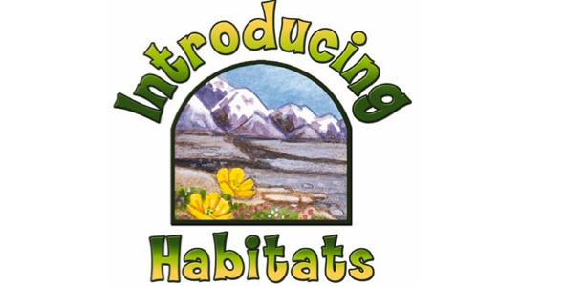

I will use this knowledge in Year 5 to ….

* Describe the differences in the lifecycles of a mammal, an amphibian, an insect and a bird.
* Describe the life process of reproduction in some plants and animals.