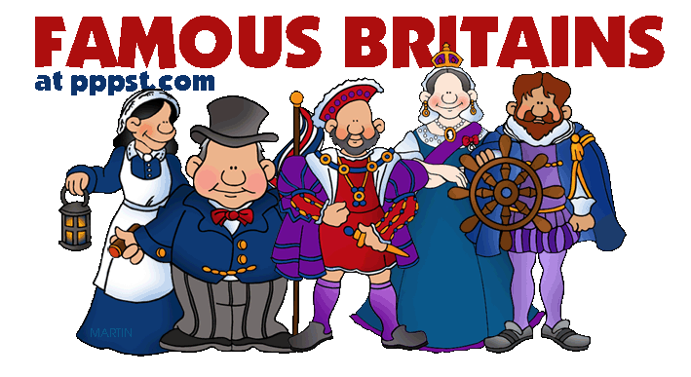

**History Year KS1**

**Learning about the lives of significant people**

In Year 1/2 I will know….

* About monarchs such as Queen Elizabeth, Queen Victoria and Henry VIII
* About well-known Tudor people who were significant in the Great Fire of London
* About Tudor monarchs Henry VIII and Elizabeth I and how they ruled.
* About Queen Elizabeth and the modern royal family, what their role is and what it means to be a monarch.
* About Mary Anning and her important discoveries in identify fossils and understanding dinosaurs.



In Year 3/4 I will know….

* about the Roman Empire and the rulers during the eruption of Mount Vesuvius
* about the significant people in ancient Greece, such as Alexander The Great and his impact on life in ancient Greece and modern Greece
* about historical vocabulary, such as empire, AD BC, ancient, civilisation and exploration
* about Stone Age Man and life in a tribe

In EYFS I knew…

* about royal families, Kings, Queens, Princes and Princesses.
* about important people in my world such as teachers, parents, nurses, doctors, and people who help us.