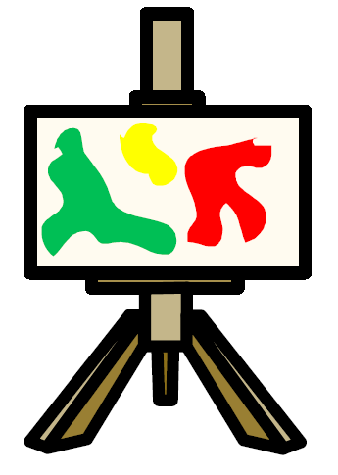
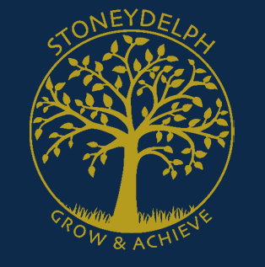

Progression of Art and Design Skills Document

Knowledge, Skills and Understanding: ART
SKILL: DRAWING
EARLY YEARS | KS1 | LKS2 | UKS2
Do they enjoy using a range of drawing implements, including pens, hands, fingers, chalks to make marks? | Can they communicate something about themselves in their drawing? | Can they begin to show facial expressions and body language in their sketches? | Do their sketches communicate emotions and a sense of self with accuracy and imagination?
Can they draw and make marks on a variety of different surfaces, including different coloured paper? | Can they create moods in their drawings? | Can they organise line, tone, shape and colour to represent figures and forms in movement? | Do they successfully use shading to create mood and feeling?  Can they organise line, tone, shape and colour to represent figures and forms in movement?
 | Can they use charcoal, pencil, crayons and pastels?
 | Can they use three different grades of pencil in their drawing (4B, 8B, HB)? | Can they use different grades of pencil shade, to show different tones and texture? | Do they successfully use shading to create mood and feeling?
 | Can they create different tones using light and dark? |  | Do they successfully use shading to create mood and feeling?
Can they start to experiment with different patterns and textures from observations, imagination and illustrations? | Can they show patterns and texture in their drawings? | Can they identify and draw simple objects, and use marks and lines to produce texture?
 | Can they use a viewfinder to focus on a specific part of an artefact before drawing it?
 |  | Can they show reflections?
 |  | Can they explain why they have chosen specific materials to draw with?
 |  |  | Can they explain why they have combined different tools to create their drawings?
 |  |  | Can they explain why they have chosen specific drawing techniques?
 |  | Can they use their sketches to produce a final piece of work?
 |  | Can they write an explanation of their sketch in notes?

Knowledge, Skills and Understanding: ART

SKILL: PAINTING
EARLY YEARS | KS1 | LKS2 | UKS2
Can they experiment with a range of different media, including different sized brushes and tools such as sponge brushes and fingers? | Can they communicate something about themselves in their painting?
 | Can they create moods in their paintings?
 | Can they choose to use thick and thin brushes as appropriate? | Can they use a range of brushes to create different effects? | Can they express their emotions accurately through their painting and sketches?
 | Can they paint a picture of something they can see?
Can they mix and match colours to different objects and artifacts? | Can they name the primary and secondary colours? | Do they know where each of the primary and secondary colours sits on the colour wheel?
Can they experiment with mixing paint to make different colours and shades? | Can they mix paint to create all the secondary colours? | Can they create all the colours they need?
 | Can they mix and match colours, predict outcomes?
 | Can they mix their own brown?
 | Can they make tints by adding white and know the vocabulary? | Do they successfully use shading to create mood and feeling?
 | Can they make tones by adding black and know the vocabulary?
 |  | Can they create a background using a wash?
 |  |  | Can they explain what their own style is?
 |  |  | Can they use a wide range of techniques in their work?
 |  |  | Can they explain why they have chosen specific painting techniques?

Knowledge, Skills and Understanding: ART

SKILL: PRINTING
EARLY YEARS | KS1 | LKS2 | UKS2
Can they create simple pictures by printing with objects of their choice? | Can they print with sponges, vegetables and fruit?
 | Can they print onto paper and textile? | Can they print onto different materials?
 | Can they design their own printing block?
 | Can they create a repeating pattern? | Can they create an accurate print design?
Can they take rubbings from objects such as coins, leaves and bricks? | Can they create a print using pressing, rolling, rubbing and stamping? | Can they print using at least four colours? | Can they print using a number of colours?
 |  |  | Can they overprint using different colours?
 |  |  | Do they look very carefully at the methods they use and make decisions about the effectiveness of their printing methods?
 | Can they create a print like a designer? |  | Can they create an accurate print design that meets a given criteria?

Knowledge, Skills and Understanding: ART

SKILL: 3D/TEXTILES
EARLY YEARS | KS1 | LKS2 | UKS2
Do they enjoy using and experimenting with a range of malleable materials such as clay, salt dough and papier mache? | Can they make a clay pot? | Can they begin to sculpt clay and other mouldable materials?
 | Can they join two finger pots together?
 | Can they add line and shape to their work? | Can they add onto their work to create texture and shape? | Can they include both visual and tactile elements in their work?
 | Can they join fabric using glue? | Can they join fabric together to form a quilt using padding?
 | Can they sew fabrics together? | Can they use more than one type of stitch? | Can they use textile and sewing skills as part of a project, e.g. hanging, textile book, etc.? This could include running stitch, cross stitch, backstitch, appliqué and/or embroidery.
 | Can they create part of a class patchwork? | Can they use sewing to add detail to a piece of work?
 |  | Can they work with life size materials? | Can they create models on a range of scales?
 |  | Can they create pop-ups?
 |  | Do they experiment with and combine materials and processes to design and make 3D form?

Knowledge, Skills and Understanding: ART

SKILL: COLLAGE
EARLY YEARS | KS1 | LKS2 | UKS2
Can they cut paper with scissors and arrange it in a pattern or picture? | Can they cut and tear paper and card for their collages? | Can they cut very accurately?  Can they overlap materials?  Can they experiment using different colours?
 | Can they gather and sort the materials they will need?
 | Can they create individual and group collages?
 | Can they use different kinds of materials on their collage and explain why they have chosen them? | Can they combine visual and tactile qualities and explain why they have chosen them?
 | Can they use repeated patterns in their collage? |  | Can they combine pattern, tone and shape?
 |  | Can they use mosaic?
 |  | Can they use montage?
 |  | Can they use ceramic mosaic to produce a piece of art?

Knowledge, Skills and Understanding: ART

 | SKILL: KNOWLEDGE
EARLY YEARS | KS1 | LKS2 | UKS2
Can they say if they like or dislike a piece of art and give a reason why? | Can they describe what they can see and like in the work of another artist? | Can they compare the work of different artists?
 | Can they ask sensible questions about a piece of art?
 | Can they link colours to natural and man-made objects?
 | Can they say how other artists have used colour, pattern and shape?
 | Can they create a piece of work in response to another artist’s work? | Can they experiment with different styles which artists have used? | Can they say what their work is influenced by?  Can they make a record about the styles and qualities in their work?
 |  | Can they explore and explain work from other cultures?
 |  | Can they explore and explain work from other periods of time?
 |  | Are they beginning to understand the viewpoints of others by looking at images of people and understand how they are feeling and what the artist is trying to express in their work?
 |  |  | Do they learn about the work of others by looking at artists’ work in books, the internet, visits to galleries and other sources of information?
 |  |  | Can they include technical aspects in their work, e.g. architectural design?

