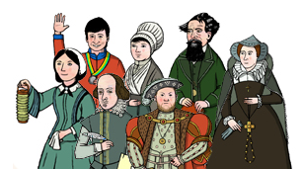
This year I will know….
- About significant Tudor leaders such as Henry VIII and how they led their people into battle and compare to Roman/Viking soldiers and battles and conquests
- About Ancient Egyptian Pharaohs and compare to Emperors from other Ancient civilisations (Maya / Shanghai)
- Know about significant figures from Tudor Era how they brought about social reform and change which then impacted on modern life.
- Know about significant figures from the Victorian Era and during WW2 how they brought about social reform and change which then impacted on modern life.

History Year 5 / 6
Learning about the lives of significant people

- Town Planner
- Archaeologist
- Film maker
- Politician
In the future this knowledge could help me to become a…
- Museum curator
- Historian
- Journalist
- Teacher

In Year 3 and 4 I knew….
- about Anglo Saxon/Roman invasion and key figures such as Julius Caesar and Boudicca and how they impacted on the world.
- about the leaders of invasion and exploration from Tudor times to Viking/Roman invasion and exploration
- about Stone Age Man and Native American Indian Tribes and how this life has shaped the modern day

