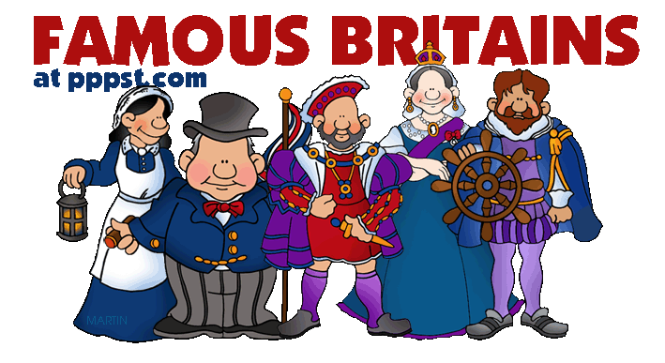
History Year KS1
Learning about the lives of significant people
In Year 1/2 I will know….
- About monarchs such as Queen Elizabeth, Queen Victoria and Henry VIII
- About well-known Tudor people who were significant in the Great Fire of London
- About Tudor monarchs Henry VIII and Elizabeth I and how they ruled.
- About Queen Elizabeth and the modern royal family, what their role is and what it means to be a monarch.
- About Mary Anning and her important discoveries in identify fossils and understanding dinosaurs.


In Year 3/4 I will know….
- about the Roman Empire and the rulers during the eruption of Mount Vesuvius
- about the significant people in ancient Greece, such as Alexander The Great and his impact on life in ancient Greece and modern Greece
- about historical vocabulary, such as empire, AD BC, ancient, civilisation and exploration
- about Stone Age Man and life in a tribe

In EYFS I knew…
- about royal families, Kings, Queens, Princes and Princesses.
- about important people in my world such as teachers, parents, nurses, doctors, and people who help us.

