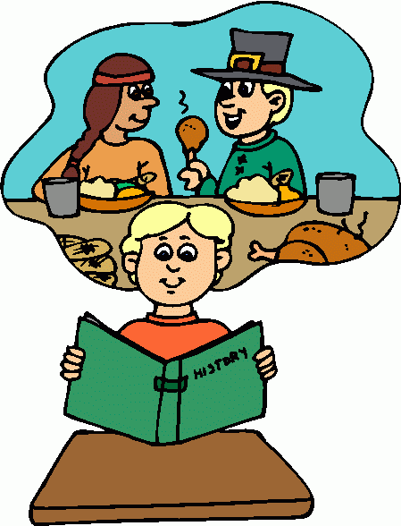
This year I will know….
- That dinosaurs lived in the past and how scientists learnt they became extinct.
- Know the roles and responsibilities of people in medieval times/in a castle/pirate times/Tudor explorers and compare to modern day.
- To learn about my own family tree and those relatives that were alive before me.
- Events in history that changed life today – Great fire of London, Titanic sinking

History Year 1/ 2
Life events beyond living memory

In EYFS I knew….
- that life in traditional stories from the past was different to life today
- that dinosaurs are creatures that lived a long time ago and are all extinct
- Guy Fawkes and St George was alive in the past
- Family members lived in different types of home and had different hobbies, jobs, food and travel to the way we live today.

- In Year 3 / 4 I will learn…

- About life in the stone, bronze and iron age and how events in modern times helps us to understand life in the past (eg: finding the Lindow man, settlement discoveries
- know about a Roman town in Pompeii, the events of the volcanic eruption and compare to homes in modern day.
- Know about the Indus Valley civilisation and life around 5500 BCE and compare to different civilisations.
- Know about life events in Greece such as; Olympics, Persian War, Battle of Marathon and compare to other events in the past

