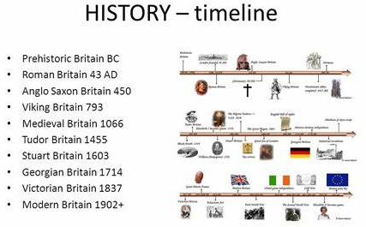
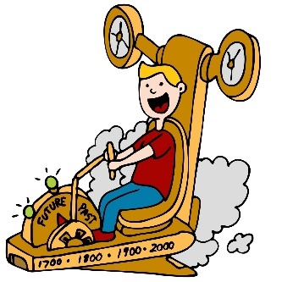
In Year 5 / 6 I will know….
- How to independently place events on a timeline for a period in history (Tudors, Egyptians)
- Remember key dates from a period of history (eg: Battle of Bosworth 1485, Death of Elizabeth 1 1603)
- Relate changes in the local area to key events in history.
- Compare differences in periods of history
- Use accurate time vocabulary to describe a period in history. How to select, organise and present timelines for a given period of history (such as WW2) or a range of periods from the past
- Sequence key events from Ancient civilizations (Maya / Shanghai), Victorian period on a timeline, explaining the changes over time using accurate historical vocabulary.
- Create from memory a timeline to show the history of Polar exploration
- Use a wide range of different evidence to collect evidence about the past.

History Year 5 / 6
Chronology and Timelines

In the future this knowledge could help me to become a…
- Museum curator
- Historian
- Journalist
- Artist
- Explorer
- Environmental scientist

In Year 4 I knew….
- How to use specific historical vocabulary including terms and periods – AD, BC, Modern, Ancient, decade, and related specific dates
- Understand specific time periods and be able to categorise them
- Place several key events on a timeline within a time period.
- military ancient, exploration, civilisation.

